

ASSET VERIFICATION AND RECORDING TOOL KIT


Plot 31, Bukoto Street
P.O Box 7657, Kampala, Uganda
+256 (0) 39 2000216/0772525235
email: cpa@cpa.ug

www.cpa.com

August to September 2026

VERIFICATION DETAILS

NAME OF THE REGION: | GREATER MASAKA
SUB-REGION:
Name of Local Government | KALUNGU DISTRICT
VERIFIER PARTICULARS
Full name | NANTUME PENNINAH/NASSALI VICTORIA K
Contact/ email and Telephone | 0760349649/0704321431
Supervisor/ Sub team leader
Name | KALYOWA LAWRENCE
Contact | 0774106047
Date of submission

HEALTH CENTRES
INFORMANT INTERVIEW/DISCUSSION GUIDE (INCHARGE OR RESPONSIBLE PERSON)

Name of Health Centre: KABAALE HEALTH CENTRE III

1a | Does the Facility have a record of all assets provided under UgIFT.  (Obtain a record and verify if it has the costs and numbers supplied | Yes
1b | If Not ask how many were supplied and when.

2 | How does this facility Maintain (repair/service/replace) the assets provided under Ugift

They receive funds

3 | Does the facility take regular record about functionality/ or breakdown of the assets provided? | Yes

4 | How has the UgIFT support helped in service delivery in the area, any issues, challenges and any recommendations for better program implementation.

Challenges
They are out dated in things they use
They don’t have enough staff
They lack profession in using these equipments

PROCEED TO VERIFICATION AFTER THIS DISCUSSION

Health centre checklist

NAME OF LG: KALUNGU DISTRICT LOCAL GOVERNMENT NAME OF HEALTH FACILITY: KABAALE HEALTH CENTRE III

Equipment/ Item | Department | Asset Number | Item  Description | Life in Months | Tag Number ( engrave no.) | Date Of Purchase | Date Placed In Service | Recoverable cost | Cost | Acc Dep Cost | Net Book Value | Ytd Deprn | Equipment status | Remarks
B.P. Machine, Digital | OPD | 2 |  |  |  | 4/6/2025 | 5/6/2025 |  |  |  |  |  | Good | Functional
B.P. Machine (Aneroid wall mounted) | MOH | 2 |  |  |  | 4/6/2025 | 5/6/2025 |  |  |  |  |  | Good | Functional
Autoclave 20 Liters.,Duo Operated
Bowl, Kick | MOH | 1 |  |  |  | 4/6/2025 | 5/6/2025 |  |  |  |  |  | Good | Functional
Bowl Stand | MOH | 1 |  |  |  | 4/6/2025 | 5/6/2025 |  |  |  |  |  | Good | Functional
Counting chamber Neubauer- Improved | MOH | 2 |  |  |  | 4/6/2025 | 5/6/2025 |  |  |  |  |  | Good | Functional
Cupboard Steel, Lockable | MOH | 2 |  |  |  | 4/6/2025 | 5/6/2025 |  |  |  |  |  | Good | Functional
Drip Stand | WARD | 8 |  |  |  | 4/6/2025 | 5/6/2025 |  |  |  |  |  | Good | Functional
ESR Stand | MOH | 1 |  |  |  | 4/6/2025 | 5/6/2025 |  |  |  |  |  | Good | Functional
Examination Couch | MOH | 2 |  |  |  | 4/6/2025 | 5/6/2025 |  |  |  |  |  | Good | Functional
Examination light,LED | MOH | 2 |  |  |  | 4/6/2025 | 5/6/2025 |  |  |  |  |  | Good | Functional
Glucometer | MOH | 2 |  |  |  | 4/6/2025 | 5/6/2025 |  |  |  |  |  | Good | Functional
Haemoglobin Meter, Digital | MOH | 2 |  |  |  | 4/6/2025 | 5/6/2025 |  |  |  |  |  | Good | Functional
Height Meter | MOH | 1 |  |  |  | 4/6/2025 | 5/6/2025 |  |  |  |  |  | Good | Functional
Instrument Trolley | MOH | 2 |  |  |  | 4/6/2025 | 5/6/2025 |  |  |  |  |  | Good | Functional
Microscope Binocular | LAB | 1 |  |  |  | 4/6/2025 | 5/6/2025 |  |  |  |  |  | Good | Functional
Otoscope | MOH | 1 |  |  |  | 4/6/2025 | 5/6/2025 |  |  |  |  |  | Good | Functional
Patient Screen | WARD | 4 |  |  |  | 4/6/2025 | 5/6/2025 |  |  |  |  |  | Good | Functional
Patient Trolley | OPD | 1 |  |  |  | 4/6/2025 | 5/6/2025 |  |  |  |  |  | Good | Functional
Refrigerator, Basic | MOH | 1 |  |  |  | 4/6/2025 | 5/6/2025 |  |  |  |  |  | Good | Functional
Stethoscope | MOH | 4 |  |  |  | 4/6/2025 | 5/6/2025 |  |  |  |  |  | Good | Functional
Stop Watch | MOH | 2 |  |  |  | 4/6/2025 | 5/6/2025 |  |  |  |  |  | Good | Functional
Stretcher | MOH | 1 |  |  |  | 4/6/2025 | 5/6/2025 |  |  |  |  |  | Good | Functional
Stove, Gas | LAB | 1 |  |  |  | 4/6/2025 | 5/6/2025 |  |  |  |  |  | Good | Functional
Weighing Scale with Height Meter, Adult | MOH | 2 |  |  |  | 4/6/2025 | 5/6/2025 |  |  |  |  |  | Good | Functional
Weighing Scale, Infant | MOH | 2 |  |  |  | 4/6/2025 | 5/6/2025 |  |  |  |  |  | Good | Functional
Weighing Scale, Toddler | MOH | 2 |  |  |  | 4/6/2025 | 5/6/2025 |  |  |  |  |  | Good | Functional
Wheel Chair
Audio Visual Equipment
Medical Waste Bin | OPD | 6 |  |  |  | 4/6/2025 | 5/6/2025 |  |  |  |  |  | Good | Functional
Wall Clock | OPD | 4 |  |  |  | 4/6/2025 | 5/6/2025 |  |  |  |  |  | Good | Functional
Diagnostic Equipment Set for MCH | MOH | 2 |  |  |  | 4/6/2025 | 5/6/2025 |  |  |  |  |  | Good | Functional
Diagnostic Equipment Set for OPD | OPD | 2 |  |  |  | 4/6/2025 | 5/6/2025 |  |  |  |  |  | Good | Functional
Glassware Set, Laboratory, Basic | LAB | 2 |  |  |  | 4/6/2025 | 5/6/2025 |  |  |  |  |  | Good | Functional
Hollow Ware Set, Treatment
Instrument Set, Dressing | MOH | 2 |  |  |  | 4/6/2025 | 5/6/2025 |  |  |  |  |  | Good | Functional
Instrument Set, Basic ENT | MOH | 3 |  |  |  | 4/6/2025 | 5/6/2025 |  |  |  |  |  | Good | Functional
Instrument Set, Suture
Pulse Oximeter, Hand held | MOH | 2 |  |  |  | 4/6/2025 | 5/6/2025 |  |  |  |  |  | Good | Functional
Bed, Adult Patient with Mattress | WARD | 10 |  |  |  | 4/6/2025 | 5/6/2025 |  |  |  |  |  | Good | Functional
Bed, Pediatric Patient, With Mattress | WARD | 5 |  |  |  | 4/6/2025 | 5/6/2025 |  |  |  |  |  | Good | Functional
Bedside Locker
Cupboard, Instrument | OPD | 1 |  |  |  | 4/6/2025 | 5/6/2025 |  |  |  |  |  | Good | Functional
Delivery Bed, Hydraulic Manual | MOH | 1 |  |  |  | 4/6/2025 | 5/6/2025 |  |  |  |  |  | Good | Functional
Oxygen Therapy Apparatus, Mininum 45L cylinder | MOH | 2 |  |  |  | 4/6/2025 | 5/6/2025 |  |  |  |  |  | Good | Functional
Resuscitator Manual, Infant, with all Mask sizes | MOH | 2 |  |  |  | 4/6/2025 | 5/6/2025 |  |  |  |  |  | Good | Functional
Resuscitator Manual, Adult, with all mask sizes | MOH | 2 |  |  |  | 4/6/2025 | 5/6/2025 |  |  |  |  |  | Good | Functional
Suction Apparatus, (Electric) | MOH | 2 |  |  |  | 4/6/2025 | 5/6/2025 |  |  |  |  |  | Good | Functional
Nebulizer, Ultrasonic | MOH | 1 |  |  |  | 4/6/2025 | 5/6/2025 |  |  |  |  |  | Good | Functional
Oxygen Concentrator, Duo Flow | MOH | 4 |  |  |  | 4/6/2025 | 5/6/2025 |  |  |  |  |  | Good | Functional
Bench | OPD | 4 |  |  |  | 4/6/2025 | 5/6/2025 |  |  |  |  |  | Good | Functional
Disinfection Buckets | OPD | 6 |  |  |  | 4/6/2025 | 5/6/2025 |  |  |  |  |  | Good | Functional
Baby Cot | MOH | 5 |  |  |  | 4/6/2025 | 5/6/2025 |  |  |  |  |  | Good | Functional
Diagnostic Equipment Set for Ward | MOH | 3 |  |  |  | 4/6/2025 | 5/6/2025 |  |  |  |  |  | Good | Functional
Hollow Ware Set, Ward | MOH | 3 |  |  |  | 4/6/2025 | 5/6/2025 |  |  |  |  |  | Good | Functional
Instrument Set, Delivery | MOH | 3 |  |  |  | 4/6/2025 | 5/6/2025 |  |  |  |  |  | Good | Functional
Instrument Set, Stitch Removing | MOH | 3 |  |  |  | 4/6/2025 | 5/6/2025 |  |  |  |  |  | Good | Functional
MVA Kit | MOH | 4 |  |  |  | 4/6/2025 | 5/6/2025 |  |  |  |  |  | Good | Functional
Stool, Laboratory | LAB | 1 |  |  |  | 4/6/2025 | 5/6/2025 |  |  |  |  |  | Good | Functional
Penguin Sucker | MOH | 3 |  |  |  | 4/6/2025 | 5/6/2025 |  |  |  |  |  | Good | Functional
Fetoscope, Dopplar | MOH | 2 |  |  |  | 4/6/2025 | 5/6/2025 |  |  |  |  |  | Good | Functional
Bubble CPAP
Centrifuge (Electric) | MOH | 2 |  |  |  | 4/6/2025 | 5/6/2025 |  |  |  |  |  | Good | Functional
Kangaroo Mother Care Chair | MOH | 1 |  |  |  | 4/6/2025 | 5/6/2025 |  |  |  |  |  | Good | Functional
Radiant Infant Warmer
Haemoglobin Meter, Sahli
Delivery Bed
Examination light
Instrument set, ENT Basic for HCIII
Bag Valve mask (Ambu Bag), Neonatal
Incubator
Office Chair | OFFICE | 7 |  |  |  | 4/6/2025 | 5/6/2025 |  |  |  |  |  | Good | Functional
Desk | OPD | 3 |  |  |  | 4/6/2025 | 5/6/2025 |  |  |  |  |  | Good | Functional
Filing Cabinet
Non Residential Buildings
Residential Buildings |  | 1 |  |  |  | 4/6/2025 | 5/6/2025 |  |  |  |  |  | Good | Functional

Signpost Reception Drip stands
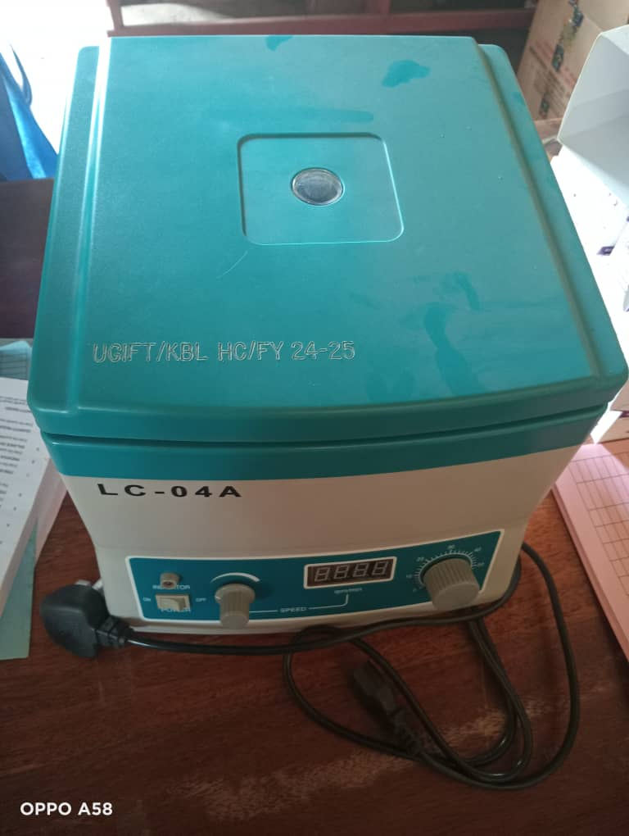
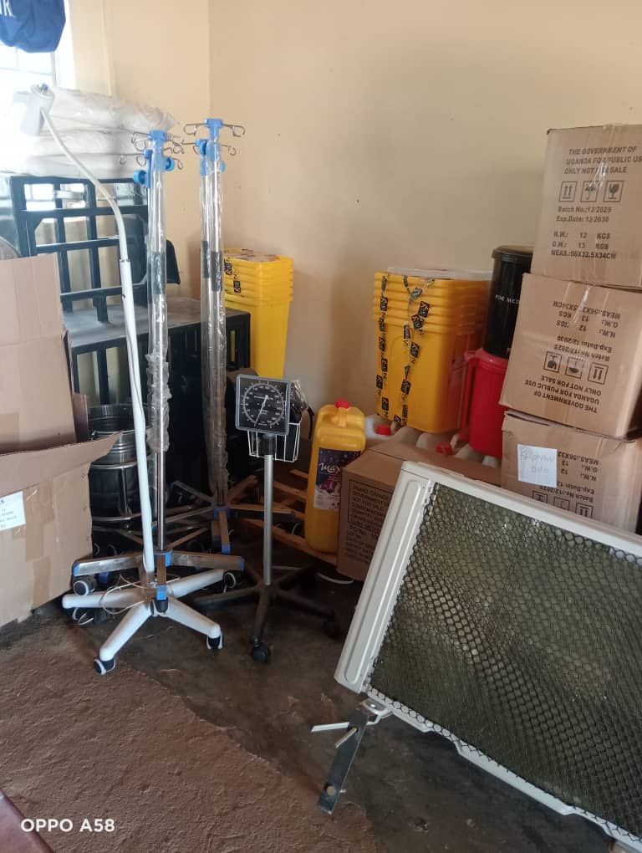
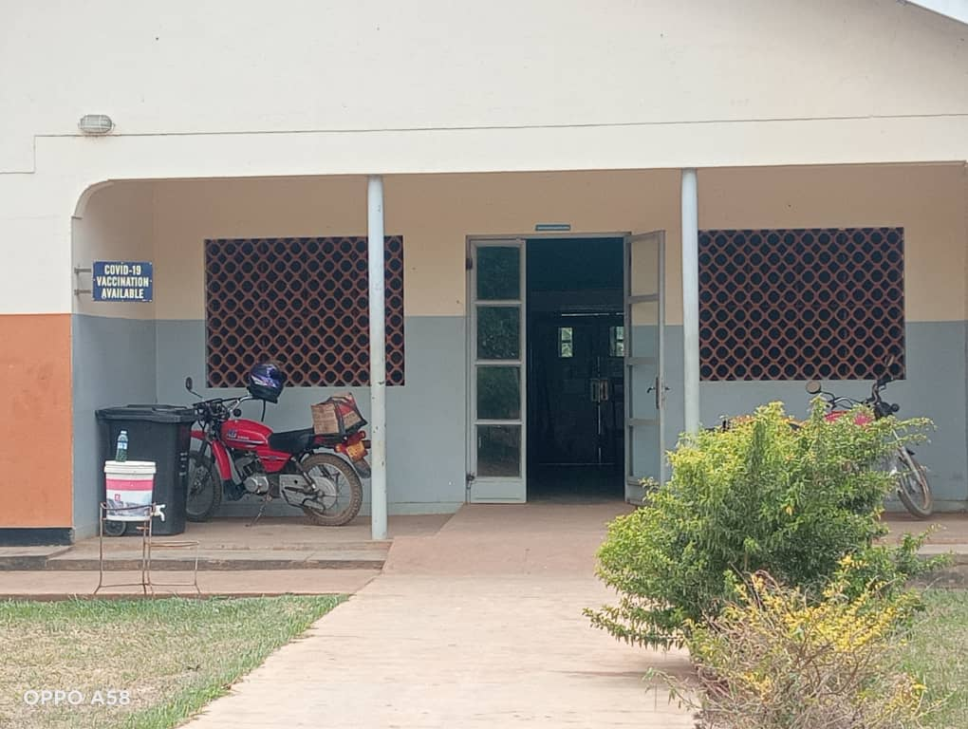

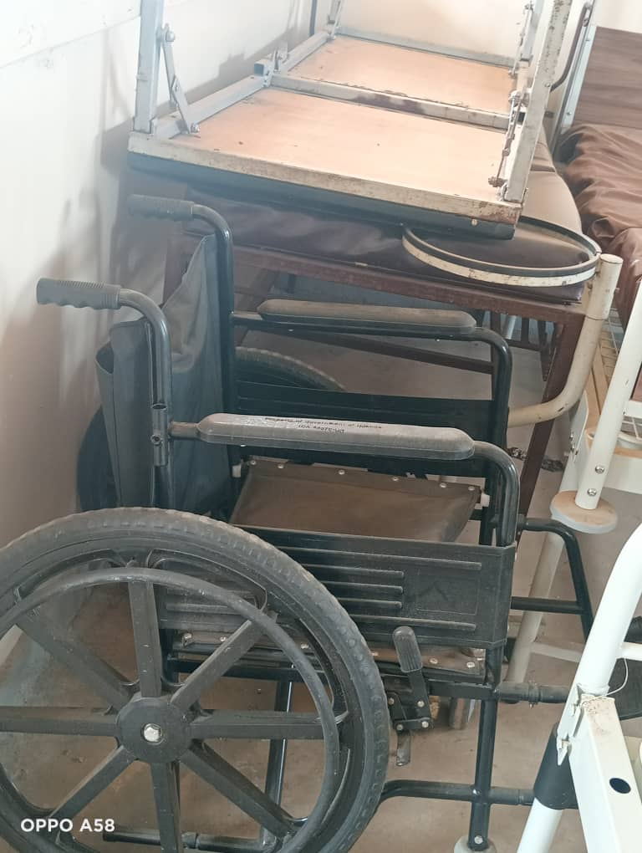
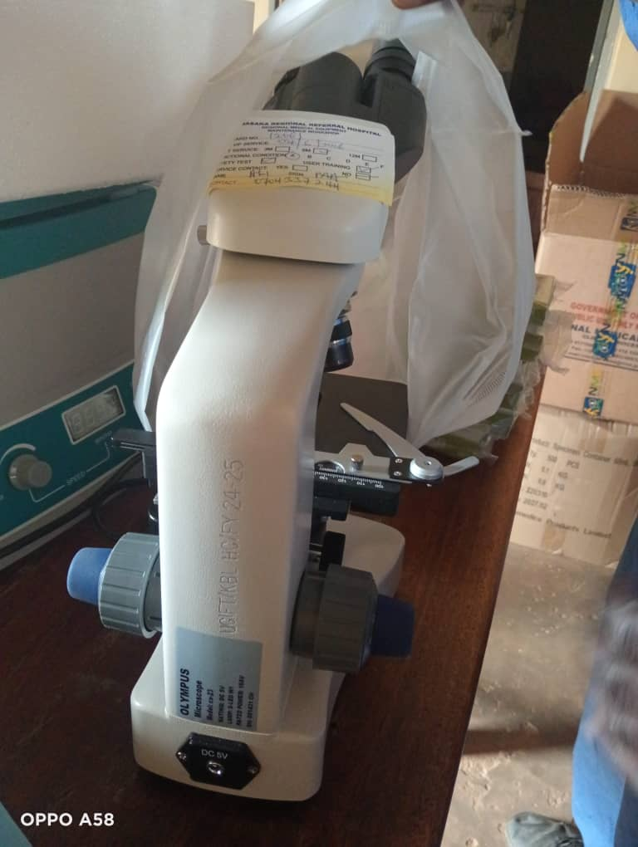

Microscope
Wheelchairs

SCHOOL VERIFICATION CHECKLIST

SCHOOL INTERVIEW/DISCUSSION GUIDE

Name of school: LUKAAYA SEED SECONDARY SCHOOL

1a | Does the Facility have a record of all assets provided under UgIFT.  (Obtain a record and verify if it has the costs and numbers supplied
1b | If Not ask how many were supplied and when.

2 | How does this facility Maintain (repair/service/replace) the assets provided under Ugift

3 | Does the facility take regular record about functionality/ or breakdown of the assets provided?  Nonfunctional/ working, and reasons for non-functionality.

4 | How has the UgIFT support helped in service delivery in the area, any issues, challenges and any recommendations for better program implementation.

PROCEED TO VERIFICATION AFTER THIS DISCUSSION

SCHOOL FURNITURE
(School Desks, Office chairs, Laboratory stools, Book shelves)

Name of LG: KALUNGU DISTRICT LOCAL GOVERNMENT Name of SCHOOL: LUKAAYA SEED SECONDARY SCHOOL

Equipment/ Item | Department | Asset Number | Item  Description | Life in Months | Tag Number ( engrave no.) | Date Of Pur | Date Placed In Service | Recoverable cost | Cost | Acc Dep Cost | Net Book Value | Ytd Deprn | Equipment status | Remarks
Desk | Education | 120 |  |  |  |  |  |  |  |  |  |  | In use | functional
Tables | Education | 52 |  |  |  |  |  |  |  |  |  |  | In use | functional
Stools | Education | 92 |  |  |  |  |  |  |  |  |  |  | In use | functional
Office cabin | Education | 2 |  |  |  |  |  |  |  |  |  |  | In use | functional

ICT ITEMS TO VERIFY
(Desktop Computer, Server Processor, Network Switch 24 Port, Multipurpose Printer, UPS, Projector, Air Conditioners, Server, CCTV Camera)

Name of LG: KALUNGU DISTRICT LOCAL GOVERNMENT Name of SCHOOL: LUKAAYA SEED SECONDARY SCHOOL

Equipment/ Item | Department | Asset Number | Item  Description | Life in Months | Tag Number ( engrave no.) | Date Of Pur | Date Placed In Service | Recoverable cost | Cost | Acc Dep Cost | Net Book Value | Ytd Deprn | Equipment status | Remarks
Computers | Education | 28 |  |  |  |  |  |  |  |  |  |  | Good | Functional
Printers | Education | 1 |  |  |  |  |  |  |  |  |  |  | Good | Functional
Projector | Education | 1 |  |  |  |  |  |  |  |  |  |  | Good | Functional
CCTV | Education | 1 |  |  |  |  |  |  |  |  |  |  | Good | Functional
Gas cylinder | Education | 2 |  |  |  |  |  |  |  |  |  |  | Good | Functional

BUILDINGS TO VERIFY
(Non- Residential and Residential, Kitchen, Toilets/Pit latrine Water tanks, Fences etc.)

Name of LG KALUNGU DISTRICT LOCAL GOVERNMENT Name of SCHOOL: LUKAAYA SEED SECONDARY SCHOOL

Equipment/ Item | Department | Asset Number | Item  Description | Life in Months | Tag Number ( engrave no.) | Date Of Pur | Date Placed In Service | Recoverable cost | Cost | Acc Dep Cost | Net Book Value | Ytd Deprn | Equipment status | Remarks
Classroom blocks | Education | 3 |  |  |  |  |  |  |  |  |  |  | Good | Functional
Multipurpose hall | Education | 1 |  |  |  |  |  |  |  |  |  |  | Good | Functional
Library/ICT block | Education | 1 |  |  |  |  |  |  |  |  |  |  | Good | Functional
Science lab | Education | 1 |  |  |  |  |  |  |  |  |  |  | Good | Functional
Tanks | Education | 2 |  |  |  |  |  |  |  |  |  |  | Good | Functional
Toilets | Education | 3 |  |  |  |  |  |  |  |  |  |  | Good | Functional
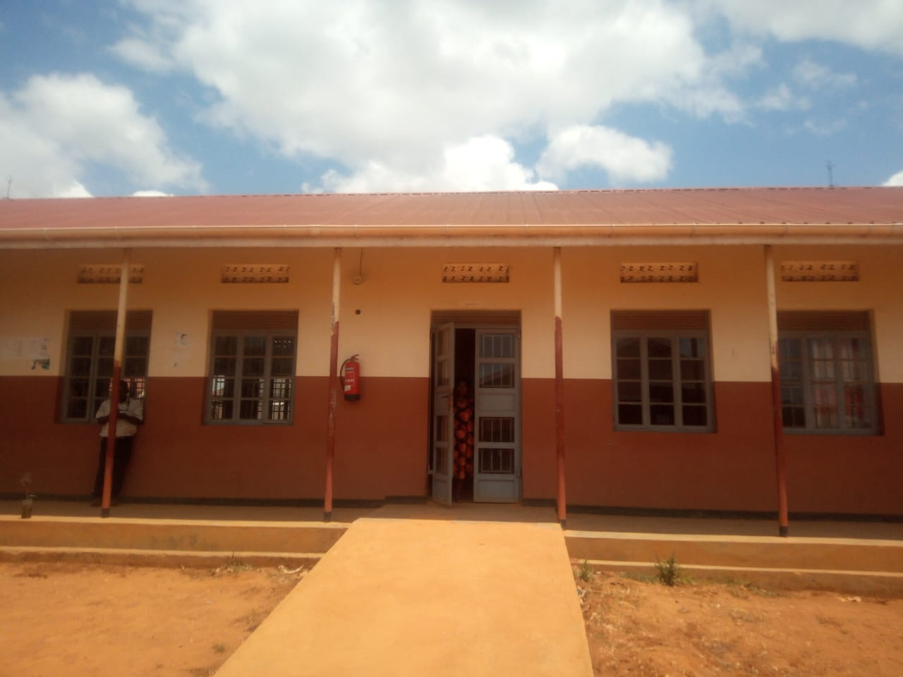
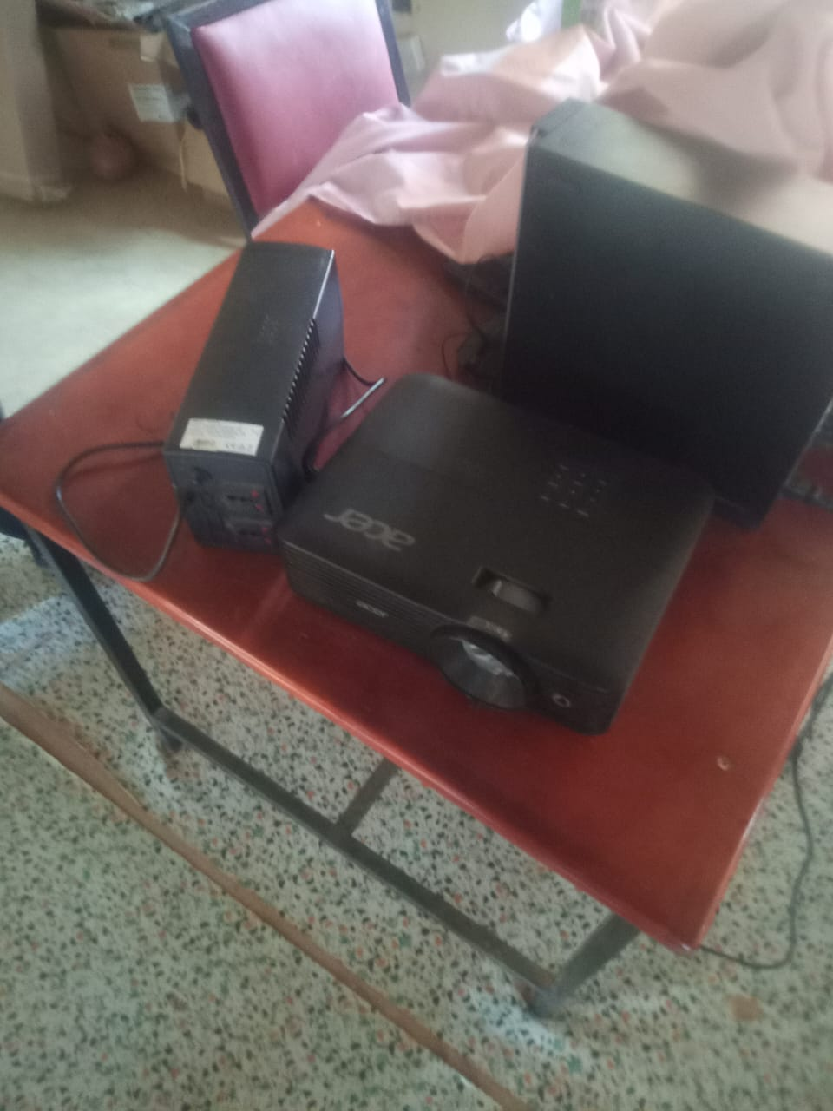
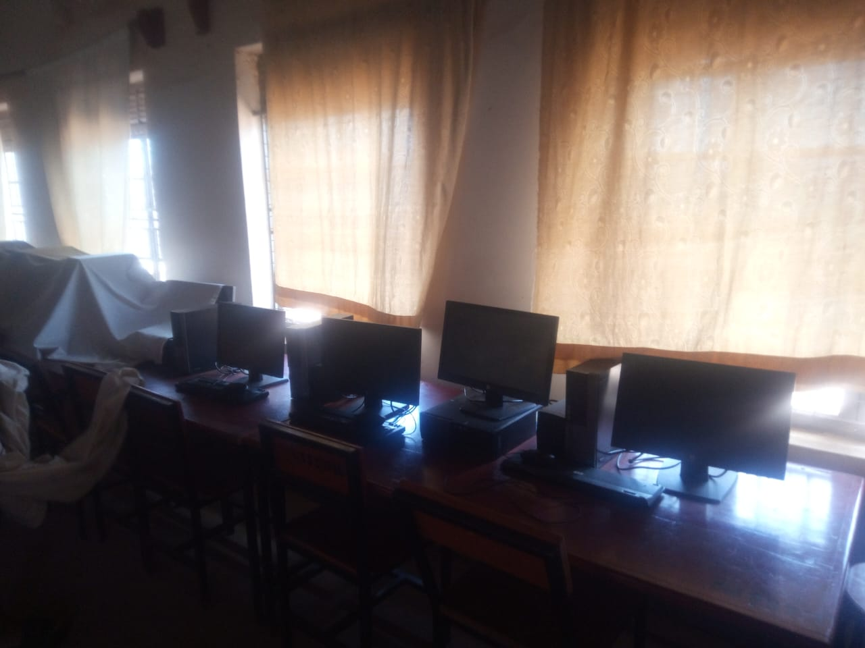
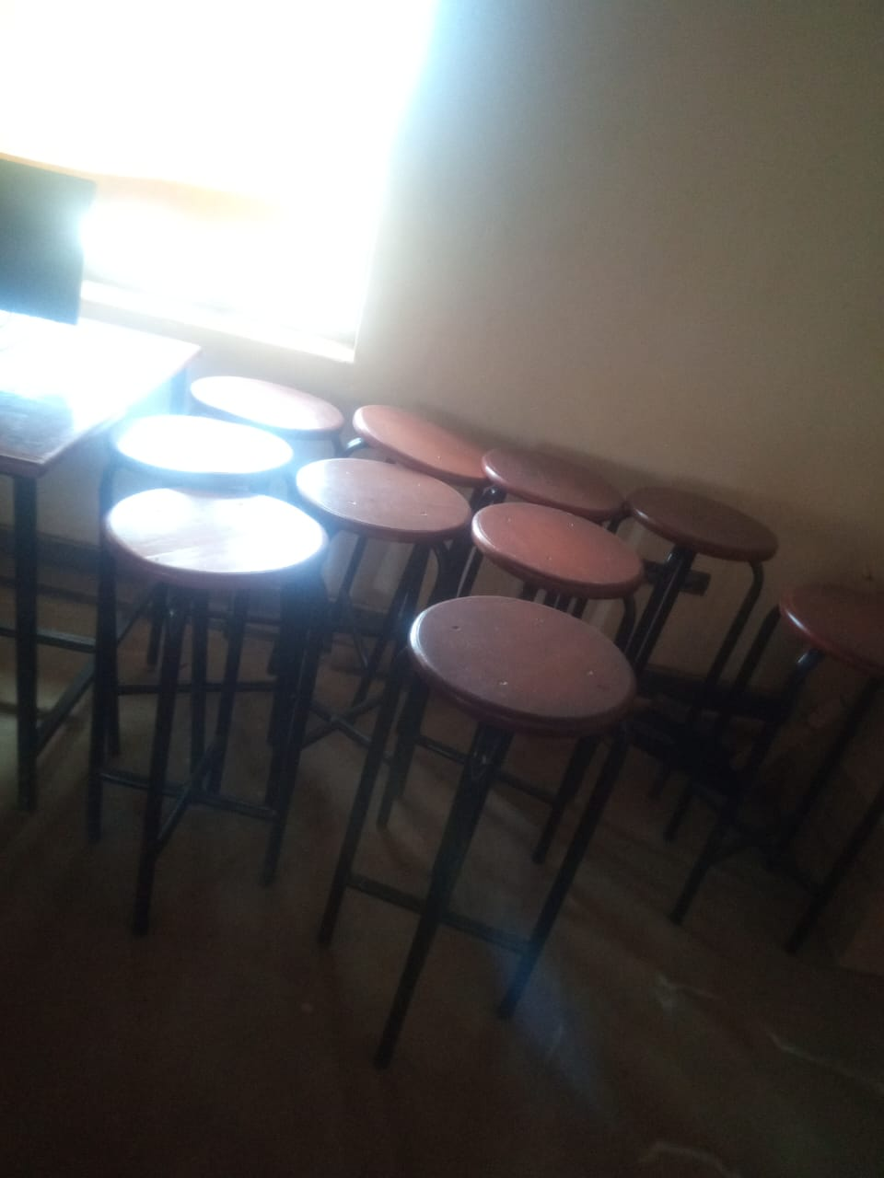

Desks Stools Computer lab Projector
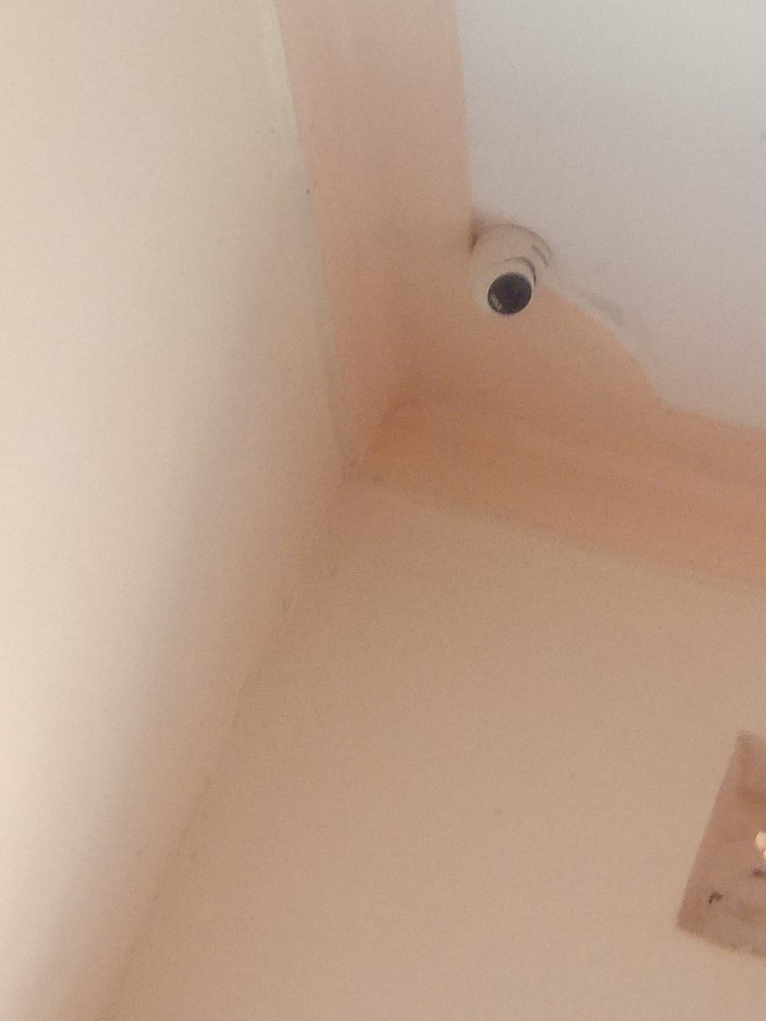
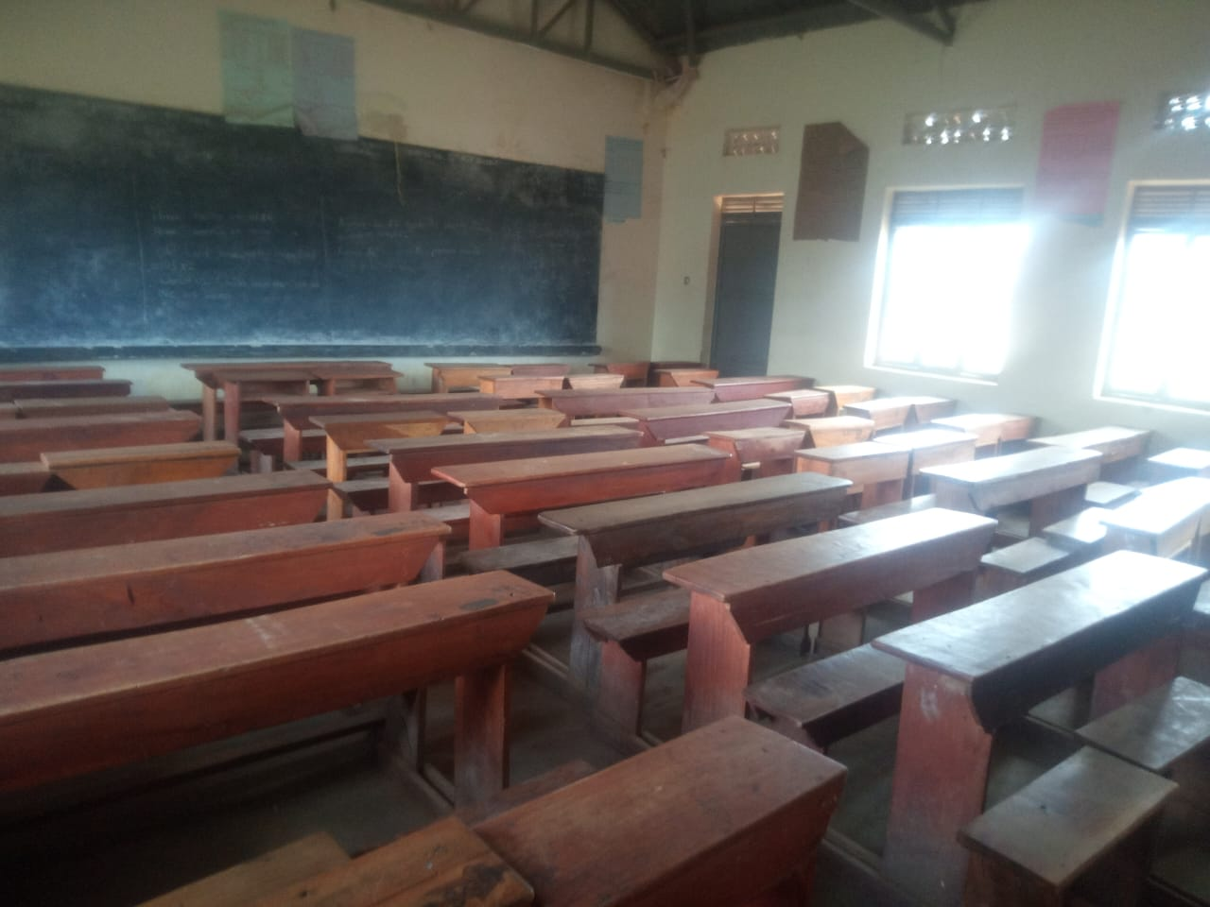

Camera
Administration block

